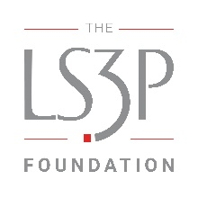

Call for Proposals - June 2026
MISSION
The LS3P Foundation was established to support leading design thinkers in advancing research, strategies, and technologies which promote transformative change, improve human and planetary well-being, increase economic mobility, and advance issues of health and social equity across the Southeast.

BACKGROUND
We live in a dynamic world. Global events, new technologies, scientific discoveries, and shifts in climate, the economy, and demographics all shape our society. Together, these forces influence where and how we live, learn, work, and play.
The LS3P Foundation’s Design Interventions Grant supports innovators who use design to anticipate, respond to, and help shape this changing landscape. We seek partners who understand how the built environment influences social outcomes and who are committed to creating a more equitable future for people across the Southeast.
The built environment includes the spaces and systems that support daily life, such as buildings, neighborhoods, public infrastructure, and landscapes. The LS3P Foundation recognizes that these environments can directly affect equity, wellness, economic mobility, and environmental health, and we support efforts that create positive, lasting change in these areas.
“A healthy, equitable community offers complete social, physical, and mental well-being to all its residents at every stage of life. In these communities, everyone feels safe, has financial stability, receives a quality education, and lives in stable, affordable housing in neighborhoods that support healthy, active living. These neighborhoods provide a clean environment, access to affordable healthy food, parks and public spaces, thriving small businesses, and places to walk, bike, and use transit. Their residents are diverse, civically engaged, and socially connected.” [i]
This is the kind of future we envision for communities across the nation, and especially throughout the Southeast.

GRANT FOCUS AREAS
The LS3P Foundation welcomes proposals aligned with its mission to create transformative changes in local communities. Proposals may focus on research, technologies, or environments and should connect to one or more of the following focus areas:
- Health Equity & Human Well-being: –Supporting emotional, mental, and/or physical health and fair and just opportunities for all people to obtain their highest level of health.
- Planetary Well-being - Supporting the integrity of the Earth’s ecosystem and securing the longevity of the planet for the well-being of all living things.
- Economic Mobility - Supporting the ability of individuals, families, or groups to improve their economic status.
- Social Equity - Supporting fairness, justice, and impartiality for all people in social policy and institutions, considering systemic inequalities and working to eliminate them.
These descriptions are intended to guide applicants, not to be prescriptive or exhaustive.
The transformative change we seek requires diverse perspectives and cannot be achieved by one person, organization, or sector alone. We welcome ideas from designers, architects, scientists, anthropologists, artists, urban planners, community leaders, and others with new or unconventional approaches that could shape southeastern communities for generations to come.

ELIGIBILITY CRITERIA
The following types of tax-exempt, nonprofit organizations may be eligible for one or more grants from the LS3P Foundation:
- Public Charities: Any nonprofit organization that is recognized as a tax exempt pursuant to IRC section 501(c)(3) and further recognized as a public charity pursuant to IRC sections 509(a)(1) and (2) is eligible to be a grantee.
- Supporting Organizations: Certain nonprofit organizations that are recognized as tax exempt pursuant to IRC section 501(c)(3) and further recognized as a public charity pursuant to IRC sections 509(a)(3) are eligible to be a grantee. These include any of a Type I, Type II, or Type III organization that is functionally integrated with its supported organization under IRC section 509(a)(3) may be eligible.
- A Type III organization that is not functionally integrated with its supported organization shall not be eligible to be a grantee.
- Governmental Units: Any federal, state, local, or tribal government unit is eligible to be a grantee.
- Educational Institutions such as colleges and universities
The LS3P Foundation shall not consider any other private foundation as an eligible grantee.
Each public charity and supporting organization must provide evidence of its tax classification, which shall include a copy of the determination letter from the Internal Revenue Service, acknowledging tax-exempt status, and additionally, in the case of a supporting organization, a well-reasoned opinion from its tax counsel regarding its tax status, on which the LS3P Foundation may rely.
The LS3P Foundation may not engage in taxable expenditures in connection with its grant program. These include an amount paid or incurred to:
- Carry on propaganda or otherwise attempt to influence legislation.
- Influence the outcome of any specific public election or carry on any voter registration drive unless certain requirements are satisfied.
- Make a grant to an individual for travel, study, or other similar purposes unless certain requirements are satisfied; or
- Carry out for a non-charitable purpose.
The intended impact of each grant should be focused on communities and regions located within a three-hour driving radius of our LS3P offices. Proposals should clearly demonstrate how the project will produce measurable and meaningful outcomes for these communities.

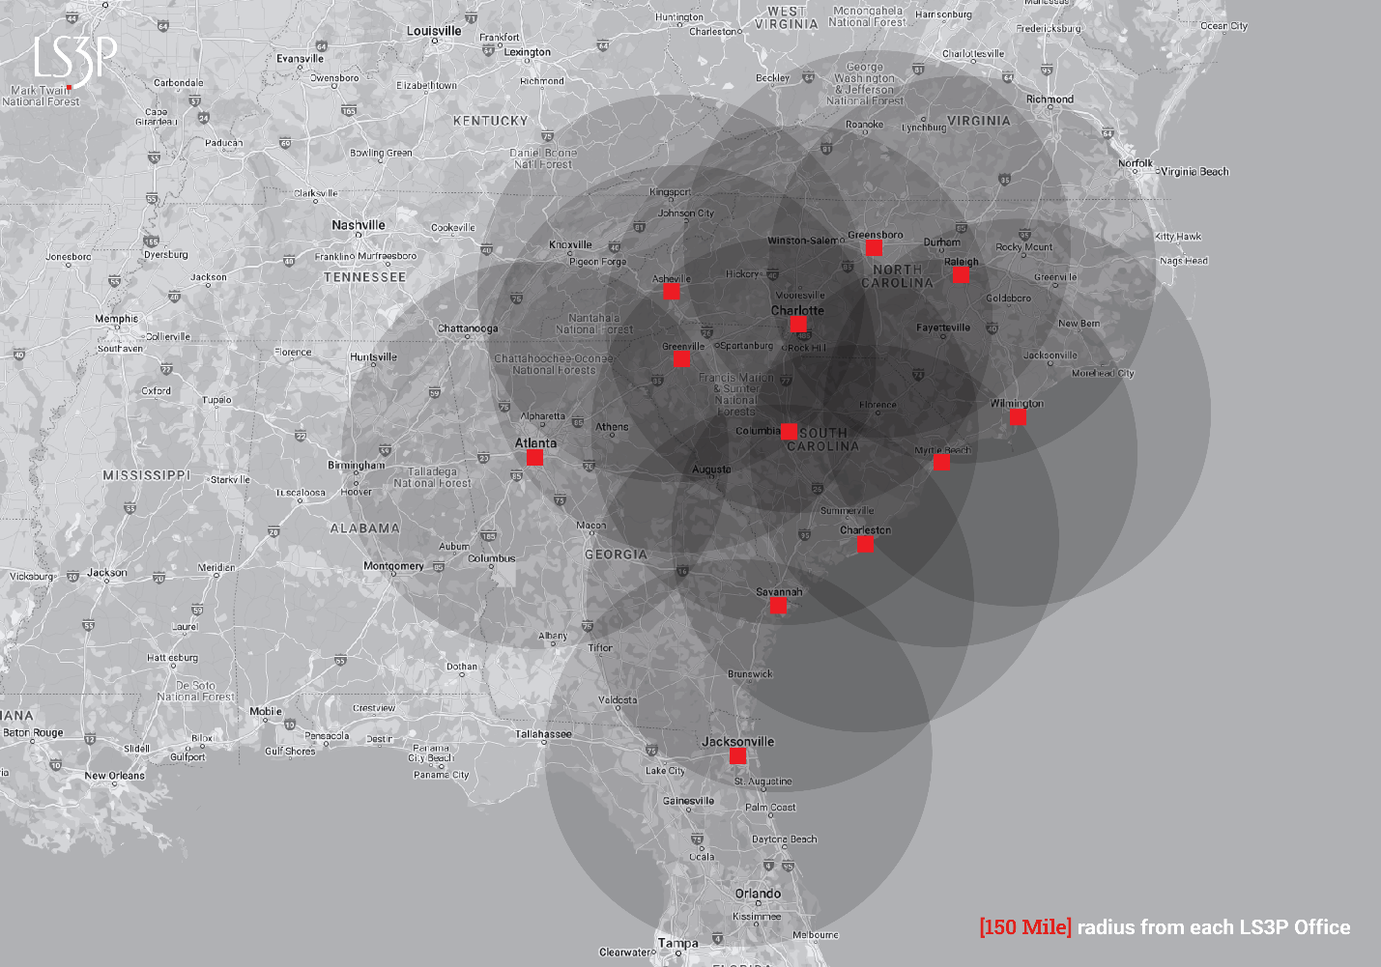

SELECTION CRITERIA
Applications will be evaluated based on, but not limited to the following criteria:
- Alignment with the Foundation’s mission. Why is your project important and relevant to you? How does this purpose align with the foundation’s mission?
- Focus on the built environment. How will this project improve the built-environment of our southeastern communities?
- Clarity of focus: How will this project increase opportunities for everyone to live the best life possible, no matter who they are, where they live, or how much money they make? Will your project address more than one area of focus?
- Impact: How will this project make a meaningful, long-term impact on the local community and become a model for other communities? Applicants should describe the outcomes they hope to achieve, how they plan to measure success over time, and what qualitative or quantitative indicators will show progress toward transformative change.
- Innovation: Is this project pioneering in one or more of these ways?
  - Offers a new take or perspective on a long-running, wicked problem.
  - Challenges, assumptions or cultural practices.
  - Takes an existing idea and gives it a new spin or a novel application.
  - Applies ideas from other fields.
  - Explores how an emerging trend will shape the future.
We welcome proposals supporting community-led housing, preservation, neighborhood infrastructure, and to academically grounded research that can inform the built-environment, practice and community outcomes. The strongest applications will pair clear public benefit with a discrete, grant-ready phase of work, such as a development stage, preservation effort, resilience improvement, resident-driven planning process, or applied research initiative. Proposals should demonstrate measurable local impact and serve as a model for broader change.

TOTAL AWARDS
Minimum award of $30,000, up to a maximum of $150,000.

OUR JUSTICE, EQUITY, DIVERSITY, AND INCLUSION COMMITMENT
The LS3P Foundation is committed to embracing the diversity of thought, background, and experience because to create designs that serve our communities, we must include everyone. Our commitment compels us to act with purpose and conviction to work towards and achieve ambitious goals for justice, equity, diversity, and inclusion. Our teams are stronger, our communities are healthier, and our work is better when we bring as many perspectives as possible to the table.

MONITORING
LS3PF monitors our grantees’ efforts and stewardship of grant funds to support accountability and learning over time. Grantees will be asked to submit narrative and financial reports at key points in the project, at minimum at the midpoint and in a final report. These updates should describe progress toward stated goals, important milestones, challenges, lessons learned, and, when appropriate, qualitative and quantitative indicators that help show change over time.

DURATION
Projects may span multiple years, but the grant will be a stand-alone amount at the time of the award. Additional grants will require added review.

GRANT TERMS AND CONDITIONS & USE OF GRANT FUNDS
Refer to Section 8a of the LS3P Foundation Grant Agreement for Grant Terms and Conditions and Use of Funds. The Grantee may be permitted to apply up to but not exceeding 25% of the Grant funds towards indirect costs in connection with performance under the Grant.

HOW TO APPLY
The grant application form is available on our website, https://ls3pfoundation.org/ Applicants should submit their responses online and attach any supporting materials via the web portal.

KEY DATES
Proposals must be received by September 25, 2026.
Decisions will be announced in November 2026.

