**Call for Proposals - June 2025**

**MISSION**

The LS3P Foundation was established to support leading design thinkers in advancing research, strategies, and technologies which promote transformative change, improve human and planetary well-being, increase economic mobility, and advance issues of health and social equity across the Southeast.

**BACKGROUND**

We live in a dynamic world. Unforeseen global events, new technologies, scientific discoveries, changes in our climate, economy, demographics, and more, profoundly impact our society. The world around us is continually shaping where and how we live, learn, work, and play.

The LS3P Foundation’s Design Interventions Grant is aimed at helping design innovators anticipate, adapt to, and influence this evolving landscape to ensure a better future. The LS3P Foundation is seeking partners who understand the connection between the built environment and social consequences and desire to help build a better, more equitable future for everyone living in the Southeast.

The built environment encompasses the curated spaces that provide the setting for human activity and is traditionally associated with buildings, cities and public infrastructure, and landscape architecture. The LS3P Foundation acknowledges the connection between the built environment and social outcomes and seeks to promote transformative positive changes where the built environment can affect equity, wellness, economic mobility, and environmental health.

“A healthy, equitable community offers complete social, physical, and mental well-being to all its residents at all stages of life. In healthy, equitable communities everyone feels safe, is financially secure, receives a good education, and lives in stable, affordable housing, in neighborhoods that make it easy to be healthy and active every day. These neighborhoods offer a clean environment, access to healthy affordable foods, parks, and public places, thriving small businesses and places to walk, bike, and use transit, and residents are diverse, civically engaged, and socially connected.” [1]

These are the communities we envision for our nation and more specifically our Southeast region.

**GRANT FOCUS AREAS**

The LS3P Foundation welcomes proposals for research, technologies, or environments that are aligned with the Foundation's mission, which is built upon the following focus areas for transformative change in our local communities:

1. **Health Equity & Human Well-being**: –Supporting emotional, mental, and/or physical health and fair and just opportunities for all people to obtain their highest level of health.
2. **Planetary Well-being** - Supporting the integrity of the Earth’s ecosystem and securing the longevity of the planet for the well-being of all living things.
3. **Economic Mobility** - Supporting the ability of individuals, families, or groups to improve their economic status.
4. **Social Equity** - Supporting fairness, justice, and impartiality for all people in social policy and institutions, considering systemic inequalities and working to eliminate them.

These descriptions are not meant to be prescriptive or exhaustive.

The transformative changes we seek require diverse perspectives and cannot be accomplished by any-one-person, organization, or sector. We want to hear from designers, architects, scientists, anthropologists, artists, urban planners, community leaders, and anyone else who has a new or unconventional idea that could alter the trajectory of our southeastern communities for generations to come.

**NOTE FOR 2025 PROPOSALS**

Last year, our grants supported initiatives that advanced Health and Social Equity. This year, while we continue to welcome diverse proposals, we are especially seeking projects that promote Economic Mobility—empowering individuals and communities to overcome barriers and build pathways to financial stability and opportunity.

**ELIGIBILITY CRITERIA**

The following types of tax-exempt, nonprofit organizations may be eligible for one or more grants from the LS3P Foundation:

* Public Charities: Any nonprofit organization that is recognized as a tax exempt pursuant to IRC section 501(c)(3) and further recognized as a public charity pursuant to IRC sections 509(a)(1) and (2) is eligible to be a grantee.
* Supporting Organizations: Certain nonprofit organizations that are recognized as tax exempt pursuant to IRC section 501(c)(3) and further recognized as a public charity pursuant to IRC sections 509(a)(3) are eligible to be a grantee. These include any of a Type I, Type II, or Type III organization that is functionally integrated with its supported organization under IRC section 509(a)(3) may be eligible.
* A Type III organization that is not functionally integrated with its supported organization shall not be eligible to be a grantee.
* Governmental Units: Any federal, state, local, or tribal government unit is eligible to be a grantee.
* Educational Institutions such as colleges and universities

The LS3P Foundation shall not consider any other private foundation as an eligible grantee.

Each public charity and supporting organization must provide evidence of its tax classification, which shall include a copy of the determination letter from the Internal Revenue Service, acknowledging tax-exempt status, and additionally, in the case of a supporting organization, a well-reasoned opinion from its tax counsel regarding its tax status, on which the LS3P Foundation may rely.

The LS3P Foundation may not engage in taxable expenditures in connection with its grant program. These include an amount paid or incurred to:

* Carry on propaganda or otherwise attempt to influence legislation.
* Influence the outcome of any specific public election or carry on any voter registration drive unless certain requirements are satisfied.
* Make a grant to an individual for travel, study, or other similar purposes unless certain requirements are satisfied; or
* Carry out for a non-charitable purpose.

The intended impact of each grant should be focused on communities and regions located within a three-hour driving radius of our LS3P offices. Proposals should clearly demonstrate how the project will produce measurable and meaningful outcomes for these communities.

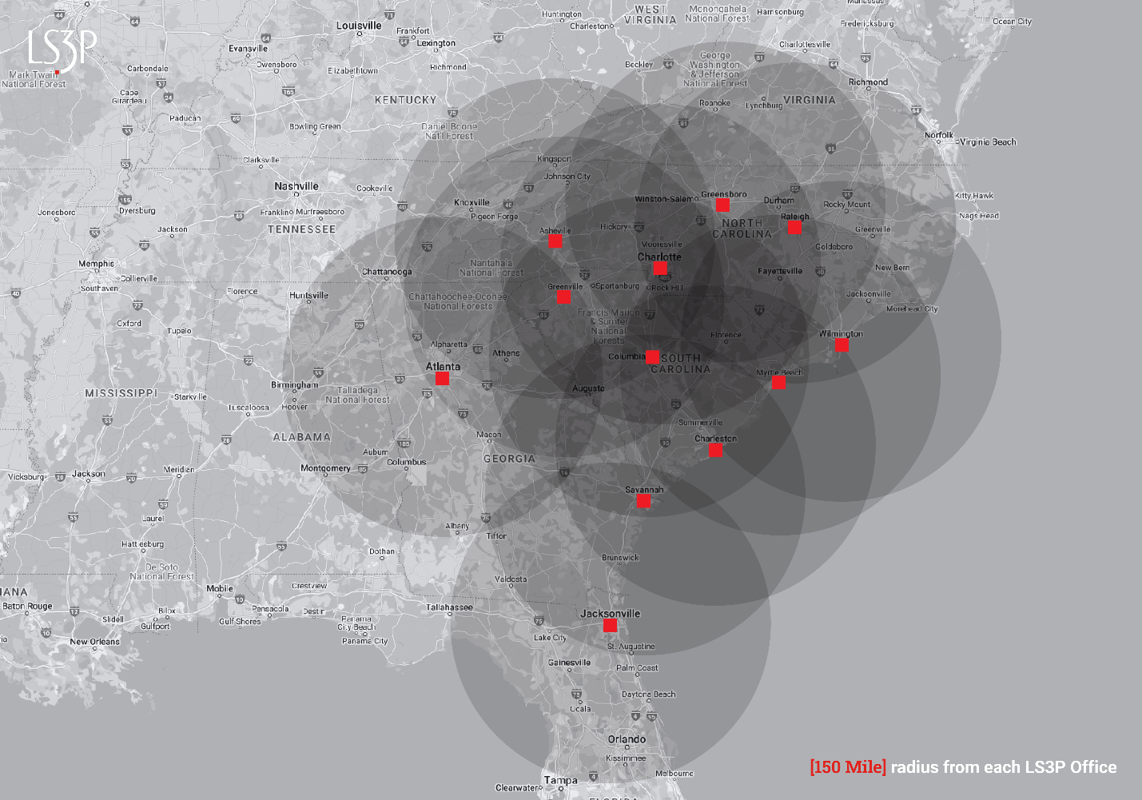

**SELECTION CRITERIA**

Applications will be evaluated based on, but not limited to the following criteria:

Focus on the built environment. How will this project improve the built environment of our southeastern communities?

* **Alignment with the Foundation’s mission**. Why is your project important and relevant to you? How does this purpose align with the foundation’s mission?
* **Clarity of focus**: How will this project increase opportunities for everyone to live the best life possible, no matter who they are, where they live, or how much money they make? Will your project address more than one area of focus?
* **Impact**: How will this project make a meaningful, long-term impact on the local community and become a model for other communities?
* I**nnovation:** Is this project pioneering in one or more of these ways?
  + Offers a new take or perspective on a long-running, wicked problem.
  + Challenges, assumptions or cultural practices.
  + Takes an existing idea and gives it a new spin—or a novel application.
  + Applies ideas from other fields,
  + Explores how an emerging trend will shape the future.

**TOTAL AWARDS**

Minimum award of $30,000, up to a maximum of $150,000.

**OUR JUSTICE, EQUITY, DIVERSITY, AND INCLUSION COMMITMENT**

The LS3P Foundation is committed to embracing the diversity of thought, background, and experience because to create designs that serve our communities, we must include everyone. Our commitment compels us to act with purpose and conviction to work towards and achieve ambitious goals for justice, equity, diversity, and inclusion. Our teams are stronger, our communities are healthier, and our work is better when we bring as many perspectives as possible to the table.

**MONITORING**

LS3PF monitors our grantees’ efforts and careful stewardship of grant funds to ensure accountability. Grantees will be required to submit periodic narrative and financial reports at a minimum of the midpoint of the project and a final report.

**DURATION**

Projects may span multiple years, but the grant will be a stand-alone amount at the time of the award. Additional grants will require added review.

**GRANT TERMS AND CONDITIONS & USE OF GRANT FUNDS**

Refer to Section 8a of the LS3P Foundation Grant Agreement for Grant Terms and Conditions and Use of Funds. The Grantee may be permitted to apply up to but not exceeding 25% of the Grant funds towards indirect costs in connection with performance under the Grant.

**HOW TO APPLY**

The grant application form is available on our website, <https://ls3pfoundation.org/> Applicants should submit their responses online and attach any supporting materials via the web portal.

**KEY DATES**

Proposals must be received by September 22, 2025.

Decisions will be announced in November 2025.

1. San Mateo County (n.d.). 10 Key Components for Building Healthy, Equitable Communities. Gethealthysmc.org. Retrieved May 1, 2023, from https://www.gethealthysmc.org/10-key-components-healthy-equitable-communities#:~:text=A%20healthy%2C%20equitable%20community%20is%20one%20that%20offers,the%20components%3A%20accessibility%2C%20affordability%2C%20stability%2C%20diversity%2C%20safety%2C%20equity.